REGULATIONS
1st Vipavska Dolina EnduroCross Challenge

1. GENERAL PROVISIONS
These regulations define the conditions for participation, competition rules, and safety requirements for the EnduroCross race, which will take place in Ajdovščina on May 8, 2026.
The organizer reserves the right to amend these regulations for safety or organizational reasons.

2. CONDITIONS FOR PARTICIPATION
- Participants must be at least 16 years old.
- Riders under 18 must provide written consent from a parent or legal guardian.
- A signed liability waiver is mandatory.
- All participants compete at their own risk.

3. CATEGORIES
Rider categories:
- Bronze: Recreational riders with little or no competition experience (16 riders)
- Silver: Riders with experience on more demanding terrain (16 riders)
- Gold: Riders with experience in demanding international competitions (16 riders)
Course layout:
- Bronze: Basic loop course
- Silver: Basic course + one advanced section
- Gold: Silver course + two additional advanced sections
The organizer may adjust categories depending on the number of entries.

4. MOTORCYCLES AND EQUIPMENT
- Enduro and motocross motorcycles are allowed.
- Motorcycles must be in proper technical condition.
Mandatory equipment:
- helmet
- goggles
- gloves
- knee and elbow protection
- protective jacket or body armor
- motocross boots
➡️ Participation is not allowed without proper equipment.

5. COURSE
- The course will be marked with tape, flags, or signs.
- It may include:
  - natural obstacles (roots, rocks, hills)
  - artificial obstacles (logs, tires, jumps)
- Leaving the marked course is strictly prohibited.
📍 Location:
Tovarniška cesta 2–4, 5270 Ajdovščina
(45.886397, 13.903351)
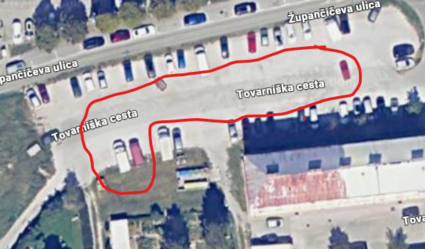

6. RACE FORMAT
10:15–11:15 – registration and track inspection
11:15–11:45 – briefing
Practice sessions:
- 11:45–12:15 – Bronze
- 12:15–12:45 – Silver
- 12:45–13:15 – Gold
Qualifying:
- 13:45–14:45 – Run 1
- 14:45–15:45 – Run 2
Races:
- 16:00–16:15 – Bronze Race 1
- 16:15–16:30 – Silver Race 1
- 16:30–16:45 – Gold Race 1
- 16:45–17:00 – Bronze Race 2
- 17:00–17:15 – Silver Race 2
- 17:15–17:30 – Gold Race 2
22:00 – Prize Giving Ceremony (after SS1 of Rally Vipavska dolina)

Additional rules:
- Each rider receives a start number and a timing transponder.
- Practice sessions are not timed.
- Qualifying runs are individual with 60-second intervals.
- The best time counts.
Start procedure:
- 2 rows of 6 riders
- engines off
- start signal: gunshot
- starting before the signal = disqualification
Disqualification:
- cutting the course
- leaving the course without returning at the same point
➡️ Race duration: 4 minutes + 1 lap

7. SCORING
1st place – 10 points
2nd place – 8 points
3rd place – 6 points
4th place – 5 points
5th place – 4 points
6th place – 3 points
7th place – 2 points
8th place – 1 point
➡️ Final results are based on total points
➡️ In case of a tie, the result of the last race decides

8. SAFETY
- Medical service must be present.
- Riders must follow marshals’ instructions.
In case of an accident:
- it is mandatory to stop and assist if necessary
➡️ Dangerous riding = disqualification

9. PENALTIES
- warning
- time penalty
- disqualification
Reasons include:
- cutting the course
- ignoring signals
- dangerous riding
- improper equipment

10. REGISTRATION AND ENTRY FEE
- Registration via email: info@amdrrtvipavskadolina.si
- or on the day of the event
Entry fee:
- until April 28, 2026 → €60
- from April 29 to May 8 → €80
- Maximum 48 riders
Included:
- warm meal
- start number
- timing transponder
Collection point:
📍 R-motoshop, Tovarniška cesta 4a
🕒 10:15–11:15

11. ENVIRONMENTAL PROTECTION
- Littering is prohibited
- Riding outside designated areas is not allowed
- Respect nature and the local community

12. FINAL PROVISIONS
- By registering, riders agree to these regulations
- The organizer is not liable for injuries or material damage
- The event may be canceled or postponed due to weather or force majeure

13. SERVICE PARK
- Opens: May 8, 2026 at 09:00
- Exit allowed only after 21:00
📍 Location:
Župančičeva ulica 4, Ajdovščina
(45.886425, 13.902813)
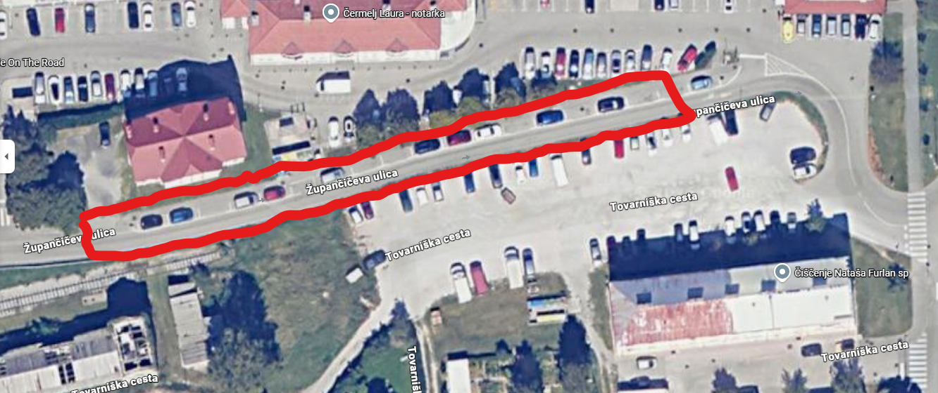

14. ASSISTANCE AND REFUELING
- Assistance is allowed only in the designated service area
- Violation = +5 minutes penalty

15. PRIZE GIVING
- At 22:00
- Bus station in front of Bartog
📍 Location:
Župančičeva ulica 8
(45.886581, 13.900756)

⚠️ NOTICE
The service park may only be exited after 21:00!

Auto Moto Club Rally Raid Team Vipavska dolina
President: Rok Jerkič

